## Modeling Uncertainty in the Earth Sciences

**SGEMS on spatial continuity models**

**Task 1**

**Open the project S-GEMSvario_A.prj**

Part A: Calculate the experimental variogram for each of the two properties in the object. Calculate the variogram for the following directions

1) five directions somewhat equally spread over the interval 0-180

2) the vertical direction

For each property, analyze and list the most important characteristics of these variograms. Can you relate this analysis to what you see in the 3D dataset. Point out the major differences between the variograms of both properties in the dataset. Report with plots.

Part B:

**Open the project S-GEMSvario_B.prj**

Calculate the experimental variogram for the 10 drill-hole datasets in three directions

1) The vertical

2) The 0-degree horizontal

3) The omni-directional variogram

Do you get “meaningful” variograms? Comment on this observation.

Repeat the exercise for the 54 well-case. Report your plots.

**Task 2**

Consider Figure 1 below. It contains two 2D slices (one XY and one XZ) of a 3D Boolean Earth model. By guessing the dimensions and relationships between the objects in this image try and recreate a 3D Boolean model such that when taking a 2D XY and XZ slide from the 3D Earth model, you can show that your Boolean model reflects reasonably well what you observe in this Figure. Note: you need not get this Figure back exactly; instead, the spatial variation needs to be similar.

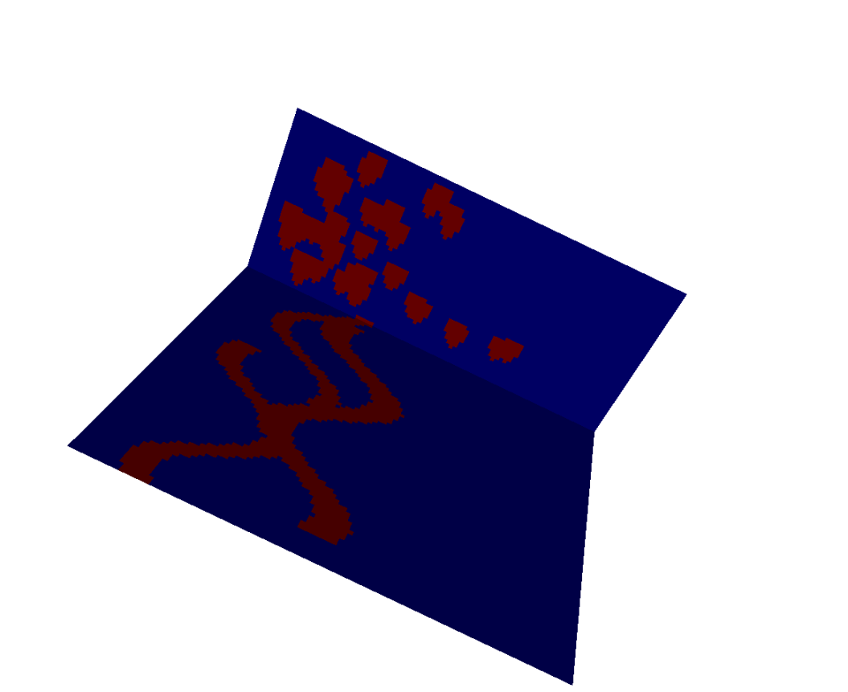

**Task 3**

Read the paper provided on coursework

*Martinius, A.W. and Naess, A, (2005) Uncertainty analysis of fluvial outcrop data for stochastic reservoir modeling, Petroleum Geoscience, vol 11, pp. 203-214*.

Outcrop data are often used to get an idea about the geology of the subsurface. Data about from several analogs in conjunction with other information can be used to create a 3D Boolean model. However, there are many issues related to using such analog information for subsurface modeling. This paper addresses these various issues.

Part A: In order to help you with the ultimate assignment in Part B, please answer the following questions based on the article provided:

1. What four sources of uncertainty are associated with using outcrop data for modeling subsurface reservoirs or aquifers?
2. What is meant by a “depositional model”?
3. What is meant in the paper by a “scenario”?
4. What physical factors influence the depositional model for fluvial systems such as described in this paper?
5. What does “anastomizing” mean?
6. In terms of shapes/geometry, what are the most important geometries that occur in these systems?

Part B: Create two scenarios for the fluvial system described in this paper, one with only ribbon sands, another with both sand bars and ribbons. In each scenario, the total proportion of sand (N:G) is fixed at 30% (deterministic). Decide on the shapes you will use for each of these objects. Use triangular distributions derived from the paper to represent the variation in dimensions.

If the Boolean Earth model were to be used as training images for multiple-point geostatistical simulations of the subsurface reservoir/outcrop, how many training images would you generate? What would be the probability you would associate with each training image?